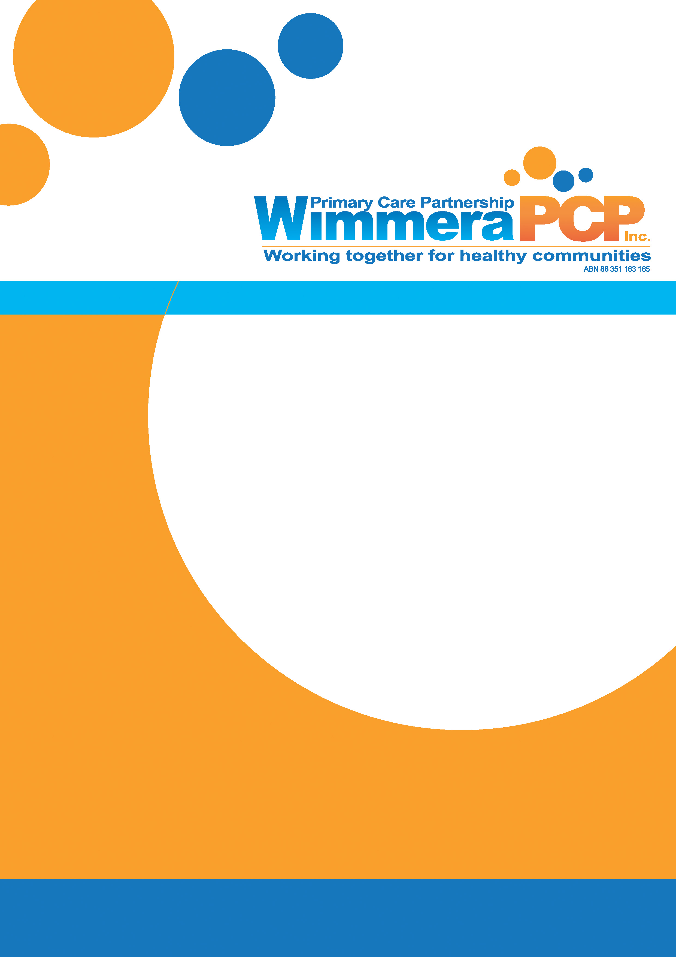
Wimmera PCP [Enter Name of Document]
[Enter date]
[Enter Revision Date if required]
Liveability Data
Social
Yarriambiack Shire
2022

SOCIAL
Social factors relate to people’s connection to their community.
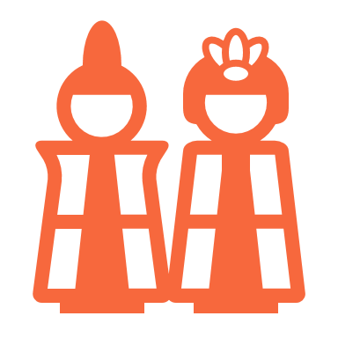
Belonging & Culture
Cultural Diversity
In 2020, the estimated Aboriginal resident population of Yarriambiack Shire was 1.3% - Regional Vic 2.0% Vic 1.0%
In 2016 the most common countries of birth of residents of Yarriambiack Shire were: Australia, England, New Zealand, India, Netherlands and Germany
In 2016, 3.1% of residents from Yarriambiack Shire were born in predominantly non-English speaking countries - Regional Vic 6.1% Vic 22.0%
Migration
Between 2000 and 2016, 0.0% of residents of Yarriambiack Shire entered Australia as permanent migrants under the Offshore Humanitarian Program - Regional Vic 0.4% Vic 1.1%
- 0.3% entered Australia as permanent migrants on a Family Stream Visa - Regional Vic 1.0% Vic 3.0%
- 0.7% entered Australia as permanent migrants on a skill stream visa - Regional Vic 1.4% Vic 5.5%
LGBTIQ+
In 2017, 1.8% of residents in Yarriambiack Shire identified as LGBTIQ+ - Regional Vic 4.5% Vic 5.7%
Sense of Belonging
In 2020, 82.0% of residents from Yarriambiack Shire agreed with the statement ‘I feel welcome here’ - Regional Vic 83.8% Vic 80.9%
- 87.9% agreed with the statement ‘I feel part of my community’ - Regional Vic 76.0% Vic 69.5%
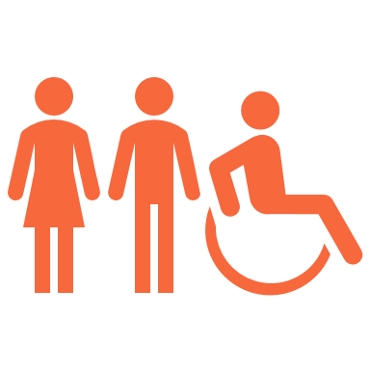
- 9.7% agreed with the statement ‘I feel like an outsider here’ – Regional Vic 16.5% Vic 25.8%
Equity & Inclusion
In 2020, 66.0% of Yarriambiack Shire residents agree with the statement ‘some groups in the community keep to themselves’ - Regional Vic 54.1% Vic 55.2%
- 30.8% agree with the statement ‘some groups who live in this community aren’t made to feel welcome’ - Regional Vic 27.5% Vic 31.5%
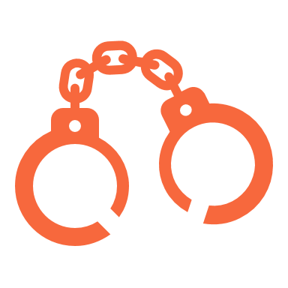
Community Safety
Crime
Crimes against persons for the year March 2019 to March 2020 (Rate per 100,000)
Offence subdivision | Yarriambiack S | Victoria
Homicide and related offences | nd | 3.1
Assault and related offences | 1,457.0 | 683.0
Sexual offences | 652.6 | 205.7
Abduction and related offences | 45.5 | 10.8
Robbery | Nd | 61.1
Stalking, harassment & threatening behaviour | 349.1 | 186.5
Dangerous & negligent acts endangering people | 151.8 | 83.8
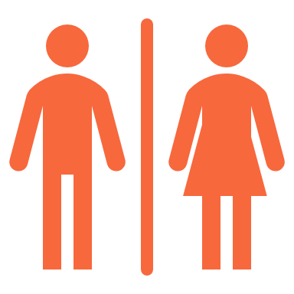
Victims of crimes (selected) against persons by sex in Yarriambiack Shire (2016 – 2019)
 | Yarriambiack S |  | Victoria
Offence subdivision | Male | Female | Male | Female
Assault and related offences | 45% | 55% | 48% | 52%
Sexual offences | 15% | 85% | 17% | 83%
Stalking, harassment & threatening behaviour | 35% | 65% | 33% | 67%
Property and deception offences for the year March 2019 to March 2020 (Rate per 100,000)
Offence subdivision | Yarriambiack S | Victoria
Arson | 15.2 | 40.6
Property damage | 591.9 | 615.4
Burglary/Break and enter | 667.8 | 648.5
Theft | 1,290.1 | 2,841.2
Deception | 333.9 | 526.0

In 2020, 2.4% of residents of Yarriambiack Shire rated crime as ’a problem’ - Regional Vic 14.5% Vic 18.6%
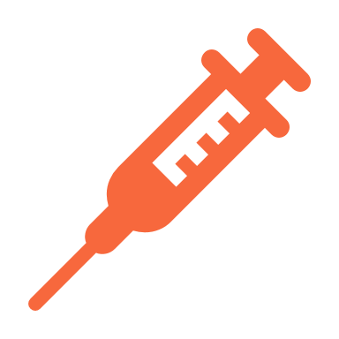
Drug Offences
Drug offences for the year March 2019 – March 2020 (Rate per 100,000)
Offence subdivision | Yarriambiack S | Victoria
Drug dealing & trafficking | 60.7 | 72.8
Cultivate or manufacture drugs | 45.5 | 22.3
Drug use and possession | 273.2 | 408.4

In 2020, 4.0% of residents of Yarriambiack Shire rated drugs as ’a problem’ - Regional Vic 26.8% Vic 20.3%
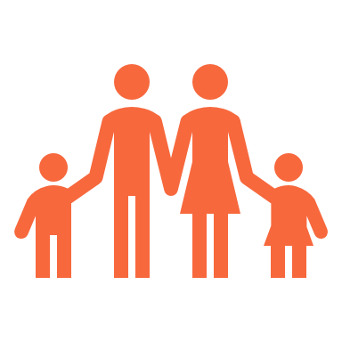
Family Violence
In 2019, there were 109 affected family members in reported family incidents in Yarriambiack Shire. The rate of affected family members was 1,652 (per 100,000) - Vic 1,282
- This represented an increase of 7.9% from 2018 - Vic 4.4%
In 2019, 76% of affected family members in reported family incidents in Yarriambiack Shire were female - Vic 75%
In 2019, 41% of affected family members were a current partner of the other party - Vic 37%
- 21% of affected family members were a former partner of the other party - Vic 26%
Between 2014 and 2019, the hospitalisation rate for injuries caused by a family member in Yarriambiack Shire was nd (per 100,000) - Regional Vic 12 Vic 14
In 2019, the proportion of males who were the other party in reported family incidents in Yarriambiack Shire was 68% - Vic 76%
Accidental Injuries
Between 2014 and 2019, the hospitalisation rate for accidental injuries for residents of Yarriambiack Shire was 2,143 (per 100,000) - Regional Vic 1,914 Vic 1,864
Between 2014 and 2019, the hospitalisation rate for accidental injuries for residents aged 65 years and over was 3,789 - Regional Vic 3,321 Vic 4,193
- The hospitalisation rate for falls for people aged over 64 years was 2,896 - Regional Vic 2,480 Vic 3,235

Accidental Deaths
Between 2013 and 2017, the rate of avoidable deaths from accidental injures (excluding suicide) in Yarriambiack Shire was 0.0 (per 100,000) - Regional Vic 19.4 Vic 13.1
- The rate of avoidable deaths from transport accidents was 0.0 - Regional Vic 8.8 Vic 4.5
Accidental Injuries by Setting
Between 2014 and 2019 the hospitalisation rates for accidental injuries by setting in Yarriambiack Shire include:
- Home 30% - Regional Vic 26% Vic 26%
- Sports 6% - Regional Vic 7% Vic 7%
- Road/Street/Highway 8% - Regional Vic 10% Vic 11%
- Working for Income 4% - Regional Vic 7% Vic 7%
- Farm 2% - Regional Vic 1% Vic 0%
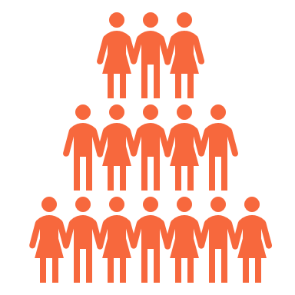
Community Strength
Demographics
Between 2016 and 2036, the projected population change for Yarriambiack Shire is ↓17% - Regional Vic 30% Vic 41%
In 2016, 16% of residents of Yarriambiack Shire live alone - Regional Vic 12% Vic 10%
Community Wellbeing
In 2020, 86.7% of residents of Yarriambiack Shire agreed with the statement that ‘my community is a great place to live’ - Regional Vic 89.0% Vic 83.2%
- 79.4% agreed with the statement that ‘this community copes pretty well when faced with challenges’ - Regional Vic 69.8% Vic 63.1%
- 61.1% agreed with the statement that ‘this community has a bright future’ - Regional Vic 76.8% Vic 77.2%
- 86.0% agreed with the statement that ‘there’s good community spirit around here - Regional Vic 80.5% Vic 74.5%
Having a Say and Being Heard
In 2020, 64.8% of residents from Yarriambiack Shire agreed with the statement that ‘the people who make decisions for my community represent the whole community’ - Regional Vic 40.7% Vic 46.0%
- 82.7% agreed with the statement that ‘most people get a fair go around here’- Regional Vic 67.2% Vic 63.2%

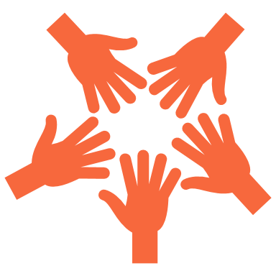
Volunteering
In 2016, 38.5% of residents of Yarriambiack Shire who were aged 15 years and over volunteered for an organisation or group - Regional Vic 24.3% Vic 19.2%
In 2020, 11.6% of residents from Yarriambiack Shire reported volunteering in their community ‘occasionally’ - Regional Vic 17.2% Vic 21.7%

Leisure, Recreation and Creativity
Getting involved
In 2020, 2.1% of residents from Yarriambiack Shire regularly attended community events such as farmers markets and community festivals - Regional Vic 8.2% Vic 15.2%
- 28.2% regularly attended meeting/social events of local clubs/groups - Regional Vic 17.4% Vic 24.5%
- 18.2% regularly take part in sports groups or teams - Regional Vic 13.5% Vic 21.5%
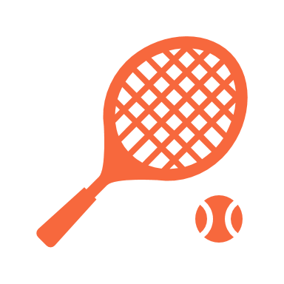
My Community Directory
In January 2021 a search on My Community Directory indicates there are 58 search results for Community Clubs and Interest Groups in Yarriambiack Shire
- There are 61 search results for Sport
- There are 11 search results for Arts & Creatives

Health & Social Services
Location of Services
- General Practitioners – Warracknabeal, Beulah, Hopetoun,
- Emergency Department – Horsham
- Urgent Care – Warracknabeal
- Acute care (inpatient) – Warracknabeal
- Public Metal Health – Horsham
- Inpatient Mental Health – Ballarat
- Public Dental Service – Dimboola, Horsham
General Practitioners
In 2016, the rate of General Practitioners in Yarriambiack Shire was 1.2 (per 1,000) - Regional Vic 2.0 Vic 2.3
- In 2020, the rate of General Partitioners sites was 1.35 (per 1,000) - Vic 0.13
Dental services
In 2016, that rate of Dental Practitioners in Yarriambiack Shire was 0.0 (per 1,000) - Regional Vic 0.4 Vic 0.5
In 2017, 28% of residents from Yarriambiack Shire delayed or avoided visiting a dentist due to cost - Vic 34%
In 2020, the waiting time for general dental care at Wimmera Health Care Group – Dimboola was 17.6 months - Vic average 13.5
- The waiting time for general denture care as 9.6 months - Vic average 18.2
Access to Health Services
In 2020, 33.3% of residents of Yarriambiack Shire rated their ‘access to general Health services’ as poor - Regional Vic 20.1% Vic 10.5%
- 49.2% rated their ‘access to mental health services’ as poor - Regional Vic 34.2% Vic 18.9%
- 54.8% rated their ‘access to specialist health services’ as poor - Regional Vic 35.9% Vic 19.0%

Nd – no data available

